FOR THE B U D D I N G L E A D ERS OF TO M ORROWThe
Leadership Cell
O U R I D E A L Sat a glance
The Leadership Cell of St. Stephen’s College has begun another journey this year with the same spirit and gusto, adding in moreefforts than the past.
The tradition of inculcating and encouraging leadership qualitiesinthe junior members has rewarded the college family with eminentalumni in the various fields of Diplomacy, Theatre, Politics andCorporate Sector. The society has the sole aim of drawing fromthese leaders, the knowledge and inspiration to excel in fields thatconstitute the core of the Indian culture . In the years that thesociety has been functional, the organization of talks, workshopsand lectures addressed by a large number of keynote speakers.
In the last 2 years we have had the honour of hosting Gen VNSharma, Dr. Arun Kumar, Shri Kpail Sibal, Ms. Sanjana Sanghi, MrAswin Sanghi and many others. This has helped hundreds of youngcurious minds to not only gather the expertise these leaders havebut also put up their opinions and views on a superior platform.
2 0 1 9 - 2 0 2 0
A glimpse of the past
Inaugural
Talk
Gen. V N Sharma
As is said, the beginning marks the success, the society began the year 2019 with the Inaugural Talk. Gen. V.N. Sharma, PVSM, AVSM, ADC (Retd.) addressed the gathering on the topic The Management of Conflict.
The recipient of the prestigious Param Vishisht Seva Medal and Ati Vishisht Seva Medal and an alumnus of
Cambridge University, he is extremely well educated and is an inspiration to any person aspiring to become a leader in the
future. He talked about his journey and leadership requirements in positions of such crucial importance followed by an open house discussion.
THE LEADERSHIP CONFERENCE
3.0
E
The Leadership Conference is an annual tradition of the society that takes place in the odd semester of the academic year, and is one of the flagship events of the college. As the name suggests, the conference brings together pioneers from diverse fields and backgrounds to share their valuable experiences, their indomitable spirit and their struggles which ultimately led them on the road to success.
Intheyear 2019, theconferencewasaseriesofinteractivesessions byeminentpersonalitiesthatincluded:-
S I
W
E
Prasun Bajpai Gautam Gambhir
H T
F O
S
A well known face, and a
well heard voice. He is a
.
.
famous Indian journalist
.
.
.
who has worked for
.
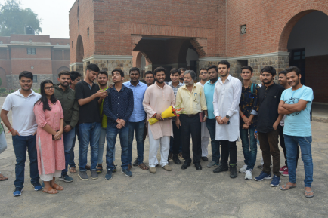
A splendid cricketer, who has made India proud on countless occasions, he is a current
D R
N O
S
several media channels and has been the
member of the Lok Sabha.
O
U
W
D
E
A
H
E
executive director of AAJ TAK.
(Due to some personal reasons, Mr. Gautam Gambhir had to cancel at the last minute.)
T
L
Black Economy The Leadership Cell
A man of immense
knowledge, Mr. Kumar has a wealth of experience in the teaching background along with the skills of an
accomplished author, having published several books on a topic widely igniting
curiosity in both the
This lecture was packed with inquisitive
questions and plethora of insights into the economy of India.
was delighted to host one of the country's leading authorities on Black
Economy - Mr. Arun Kumar, to bring out the economist in its audience.
students and teachers minds.
Reigning
Perspective
Keeping up with the tradition of discussions on India and the neighboring countries’ relations, The Leadership Cell was
honoured to host The Reigning Perspective.
Dr. Happymon Jacob
Dr. Happymon Jacob, a pioneer in the subject of Arms control and disarmament to talk about India’s New Foreign Policy. He has published several works including Kashmir & Indo-Pak Relations: Politics of Reconcillation (2013), The Line of Control: Travelling with the Indian and Pakistani Armies(2018).
Mr. Manjeev Singh Puri
To carry forward the enlightening discourse, we also had Mr. Manjeev Singh Puri, an alumnus of St. Stephen's College and the Ambassador of India to Nepal. With a diplomatic career spanning over 38 years, he shed light on the prospect of SAARC in building a prosperous neighbourhood.
THE DIALOG
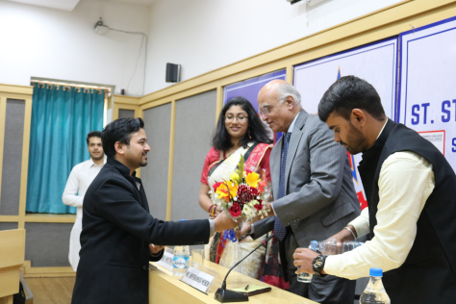
In the year 2o19-20, eminent personalities like Shri Kapil Sibal, an immaculate lawyer and an almnus of St. Stephen’s College, Mr. Shivshankar Menon an Indian Diplomat and ex-National Security Adviser of India under Prime Minister of India Manmohan Singh.
Mr. Sibal addressed the college community on the nation’s development precariously standing on the pillars of politics while Mr. Menon focused on reviewing India’s way forward in a changing world.
2 0 2 0 - 2 0 2 1
Journey of the Lcell
PAPER
PRESENTATION
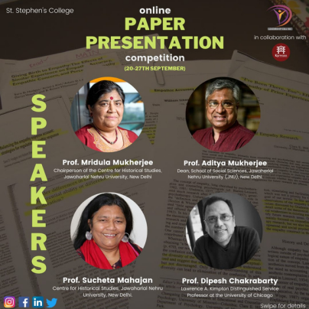
We began the year 2020 with the Paper Presentation Competition. It was a part of the student carnival named 'Jashn -e- Tarikh' that aimsto inculcate the knowledge of
Indian History and Culture through various Talks, Events and Competitions. A week-long competition starting with an Online Inaugural Session with the judges, and the Paper Presentation & Result Day later.
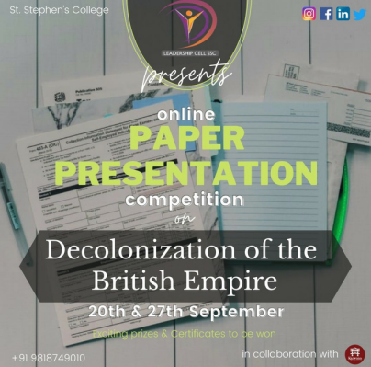
We were extremely honoured by the prescence of our esteemed panel of judges Prof. Mridula Mukherjee, Prof. Aditya Mukherjee , Prof. Sucheta Mahajan and Prof. Dipesh Chakrabarty.
THE LEADERSHIP
CONFERENCE
3.0
The Leadership Conference, as the name suggests, brings together pioneers from diverse fields and backgrounds to share their valuable experiences, their indomitable spirit and their struggles which ultimately led them on the road to success.
The Leadership Conference 2020 was a series of interactive sessions by eminent personalitiesthat included Ms. Sanjana Sanghi, the young and multi talented actress, the bestselling author Mr. Ashwin Sanghi, Mr. Sanjiv Bhikchandani, the founder of Naukri.com and Shaadi.com, the young chess master and youth icon Mr. Vidit Gujrati and the co-founder of Cloudmark and Topsy Mr. Vipul Ved Prakash.
This 2 day eventsaw a huge footfall with the audience so thrilled to interact with such amazing speakers and learn from them.
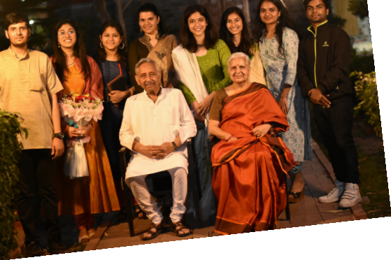
Politics form the core to this country and is a pillar in the social community. Every year the Leadership Cell tries to bring forward the background setups of politics in front of hundreds of students within the college community to make them aware about the structure and roles politics play in their lives.
he was a nominated member of parliament from Rajya Sabha.
The
Symposium
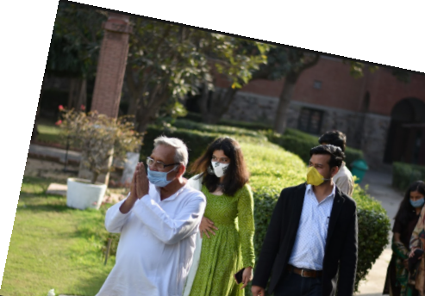
We invite faces from diverging political background to brainstorm policies and strategies that reign the current discourse of events and also provide a platform to the audience to put up their views.
We are proud to host Mr. Mani Shankar Aiyyar on the 27th of Februrary, an Indian politician and former career civil servant diplomat. A member of the Indian National Congress Party, he was a nominated member of parliament from Rajya Sabha.
The
Dialog'21As a wonderful end to the great academic session, we had the opportunity to have an interactive evening offline with a very
popular name among the student community. We were graced
by the prescence of Ms. Tina Dabi on the 6th of March.
An IAS Officer of the 2016 batch. She had topped the exam by securing All India Rank One. She is currently the Joint Secretary Finance (Tax) to the Govt of Rajasthan and Honorary Advisor BRICS Chamber of Commerce & Industry YLP.
She joined usfor an interaction about college life in DU, giving insights into her prep for the IAS Exam. An insight into the lifestyle and schedule of a AIR 1 gave the audience some amazing ideas to i corporate into their everyday schedules.
2 0 2 1 - 2 0 2 2
A foray to the future
L E A D E R S H I P C E L L
P R E S E N T S
Council 2021-2022 I
I
P R E S I D E N T
C
I
O
R
Bronia Mathews
D
U
N
Y
C
E
I
A
L
V I C E - P R E S I D E N T Aryan Shaw
V I C E - P R E S I D E N T R
Manas Kumar
G E N E R A L S E C R E T A R Y Nanda Agrawal
R
A E Y
D N
LI
C
N U
O
J T - S E C R E T A R Y Kartikay Singhal
M E D I A & P U B L I C I T Y H E A D
Sashwat Pandey
Ayiesha Gauher
T R E A S U R E R
Veeradittya Podder
E X E C U T I V E M E M B E R S Pankaj Yadav
J T - S E C R E T A R Y Ujjwal Kumar
M E D I A & P U B L I C I T Y H E A D
Papatla Akash
Sahil Mark Jacob
I I
C
Ksitij Jain^{Sudhanshu Thakur} E X T E N D E D C O U N C I L
Aryan Kathuria
Tanvi Singal Kajol Gahtyari Nikita Saini Falit Sijariya Rudraksh Dua
Our future
plans..
The Public Policy Program
The Public Policy Program is something we would want to venture into in the coming year. The idea beghind it is to
conduct a live project in collaboration with emminent public policy framers of the country. The audience and
particpants will get a first hand chnce to see the nuance sof a policy formation and how the descion makers of the country analyse, plan and formulate.
The Parliament Visit
It is a tradition of the society where a bunch of curious minds set out on a journey to visit the Lok Sabha, the Temple of Democracy. This event mainly focused on deepening the students understanding of government process while attempting to bridge the prevalent disconnect they have with the system by actually helping them view it in live.
The visit though planned for 20-19-20, had to be laid on hold due to security reasons. We aim to do so in the coming year to make up for what was missed.
Lokniti
The LokNiTi is a powerful forum to discuss public policy with the experts in the field. The year 2018-19 saw the eminent Shri. Rajiv Mehrishi, the Controller and Auditor General of India (CAG) . .
In the year 2019-20, though we had planned and organized the event, the unpprecedented situation due to the pandemic pulled us back. However, in the coming year we plan to continue hosting the same as one of our flagship events with emminent speakers to motivate us.
Youth Parliaments
To give the students, a taste of the Indian parliament, the society will organize a Youth Parliament this year. The main aim behind this would be to provide a platform that enables young people to be effective and expressive agents of change. It would focus on various agendas related with the nation and help the students to conceptualize and execute their own projects and initiatives working with socio-cultural, economic, legal and environmental issues they are passionate about in an environment that is solely established in order to execute it
Our
Speakers OVE R THE YEAR S
_{Mr. Brij Pahwa Dr} ^{Mr. Kazim Rizwi} . Amna Mirza Mrs. Sagarika Ghose ^{Gen. V N Sharma} Dr. Happymon Jacob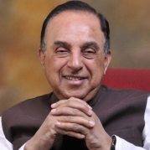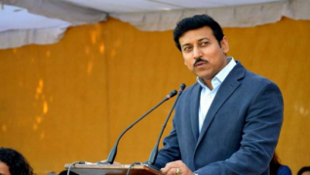
^{Mr. Shiv Aroor} Mr. P. Sainath Mr. Rajyavardhan Singh Rathore Mr. Subramanian Swamy Mr. Shivinder Mohan Singh Mr. Sachin Pilot 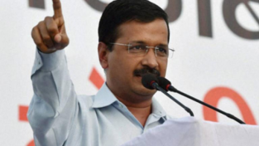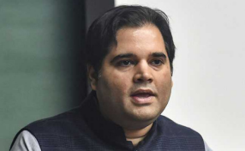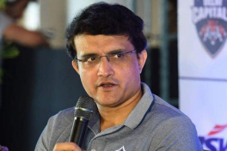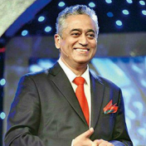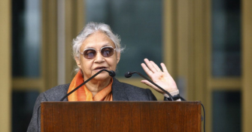Mr. Kapil Dev Mr. Arvind Kejriwal _{Mr. Varun Gandhi} ^{Mr. Sourav Ganguly} _{M} ^{Mr. Rajdeep Sardesai} rs. Sheila Dixit
Mr. Shiv Khera Mr. Vidit Gujrathi Mr. Ashwin Sanghi Ms. Sanjana Sanghi^{Mr. Sanjeev Bikhchandani} _{Mr. Amitabh Kant} Mr. Vipul Ved Prakash
_{Mr. Mani Shankar Aiyar} Ms. Tina Dabi
Mr. Kap Mr. Shiv Shankar Menon ^{Mr. Manjeev Singh Puri} il Sibal

